**Answers – Review Worksheet: Blood Glucose Regulation**

1: Define each of the following terms and describe its role in blood glucose homeostasis:

(10 marks)

Glycogenesis: *The process of removal of glucose (0.5) from the blood and conversion to glycogen (0.5) for storage in the liver (0.5) to decrease blood glucose levels (0.5)*

Glycogenolysis: *Breakdown of stored glycogen to glucose (0.5) in the liver (0.5), and release of that glucose into the blood (0.5) to increase blood glucose levels.(0.5)*

Gluconeogenesis: *Conversion of proteins to glucose in the liver and the release of that glucose into the blood to increase blood glucose levels.*

Lipogenesis: *Conversion of excess glucose (0.5) into fat (0.5) in the liver and fat cells (0.5), after glycogen storage is full. (0.5)*

Lipolysis: *Conversion of fat (0.5) into glucose (0.5) in liver and fat cells (0.5) and release into the blood to increase blood glucose levels. (0.5)*

2: Write a word equation for cellular respiration and explain its significance in glucose homeostasis.

(4 marks)

*Glucose + Oxygen 🡪 Carbon Dioxide + Water + ATP (+ heat energy) (1)*

*Cellular respiration occurs in the mitochondria (1) and is significant in glucose homeostasis because the process requires a steady supply of glucose (1) which must enter cells from the blood stream (1) so that it can reach the mitochondria.*

3: Lily goes for a 5 km run after she wakes up in the morning.

1. What would be the expected effect on Lily’s blood glucose levels during her 5km run and why?

(3 marks)

*Lily’s blood glucose levels would fall (1) as the exercise would require additional cellular respiration (1) which uses glucose from the bloodstream. (1)*

1. Draw an annotated steady-state control model to show how blood glucose homeostasis would occur during Lily’s run:

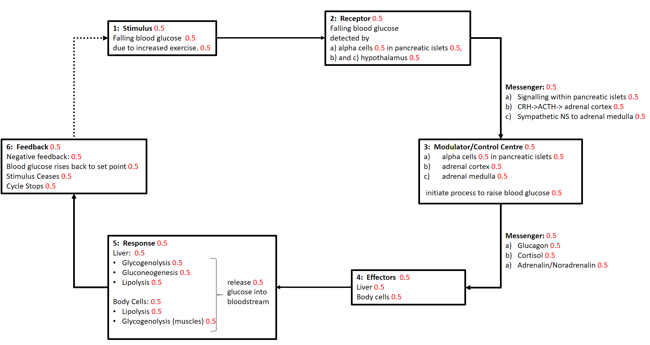(15 marks – 18 marks available in key)

4: After her run, Lily goes out for breakfast.

1. What would be the expected effect on Lily’s blood sugar levels after eating breakfast and why?

(3 marks)

*Lily’s blood glucose levels would rise (1) as the food she eats is digested and glucose (1) is absorbed into the bloodstream (1)*

1. Draw and annotated feedback loop to show how blood glucose homeostasis would occur after Lily’s meal.

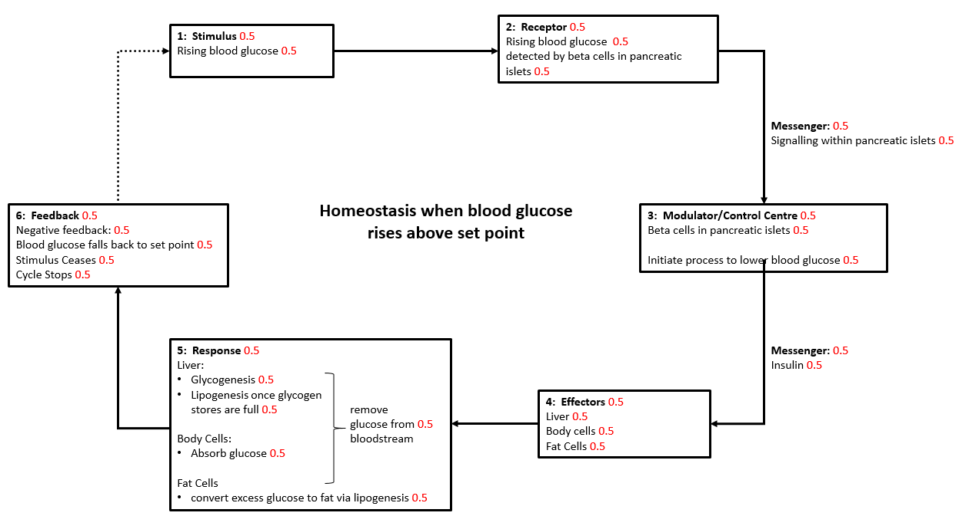(12 marks)

5: Peter has a normally functioning endocrine pancreas and is in good health. Does his blood glucose stay at the homeostatic set point all day? Explain your answer.

(6 marks)

*No, Peter’s blood glucose does not stay at the homeostatic set point all day (1). Homeostasis is a dynamic equilibrium (1), meaning that it fluctuates within a narrow range of values (1). Peter has a normally functioning pancreas, so his blood sugar will fluctuate but will not exceed the tolerance limits (1) due to homeostatic mechanisms which will act to keep his blood glucose within a narrow range. The tolerance limits are the upper and lower limits (1) beyond which normal function is impaired (1).*

6: Insulin is an amine hormone. Describe in general how amine hormones have their effect on cells.

(5 marks)

*Amine hormones bind to a receptor (1) on the cell surface (1). This activates a second messenger (1) that activates enzyme amplification (1) within the cell which then affects the cell’s function (1)*

7: Cortisol is a steroid hormone. Describe how steroid hormones have their effect on cells.

(7 marks)

*Steroid hormones are able to diffuse across the cell membrane (1) as they are lipid soluble (1). They bind to receptors on the nucleus or other organelles (1) The hormone-receptor complex (1) activates genes (1) controlling formation of particular proteins (1) that affect the cell’s function (1).*